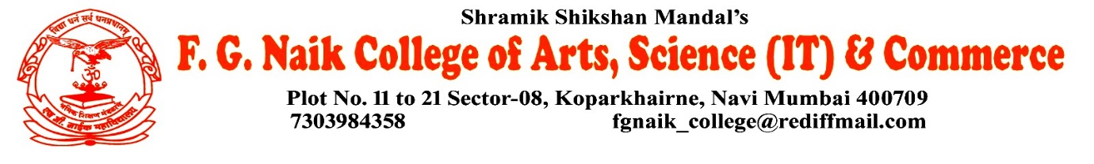

NSS UNIT
LECTURE ON TRAFFIC RULES AWARENESS
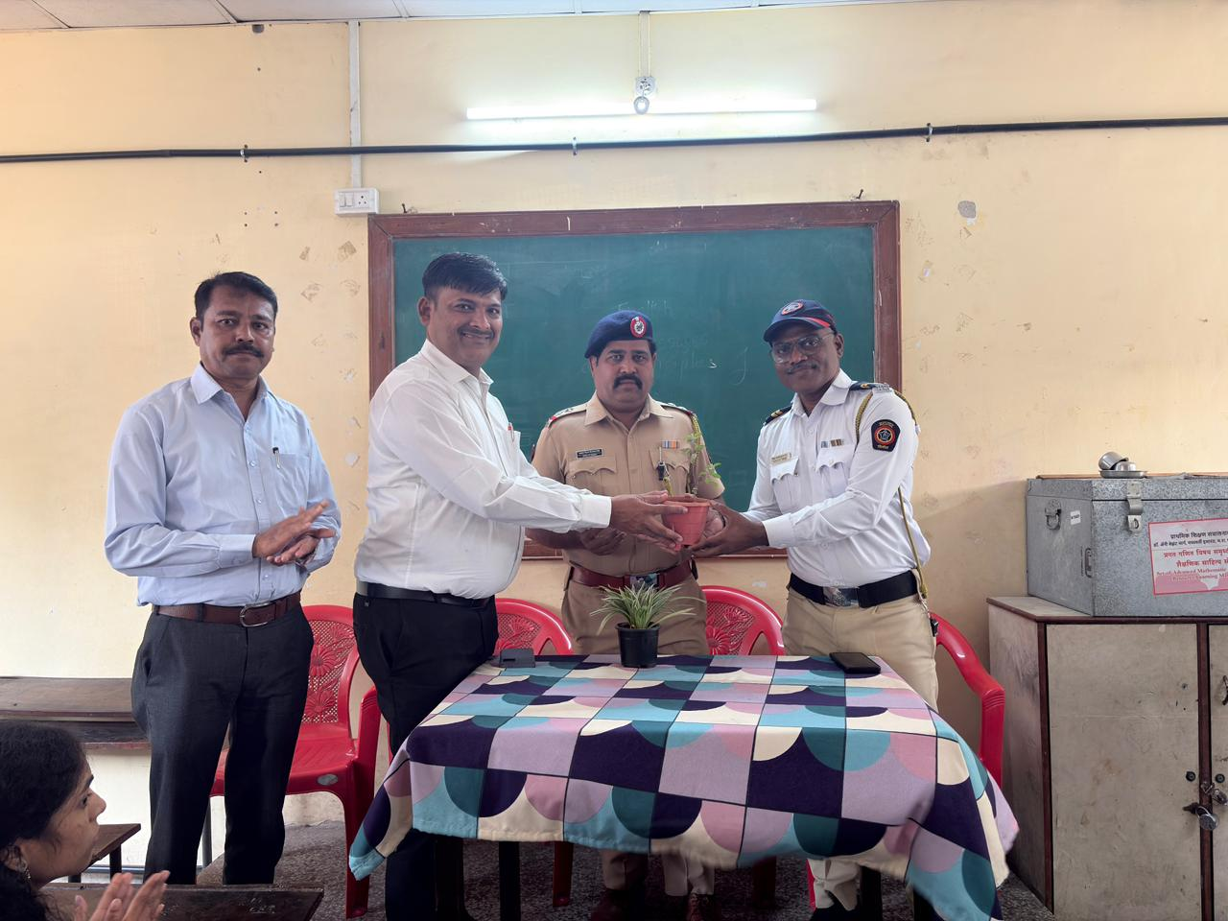
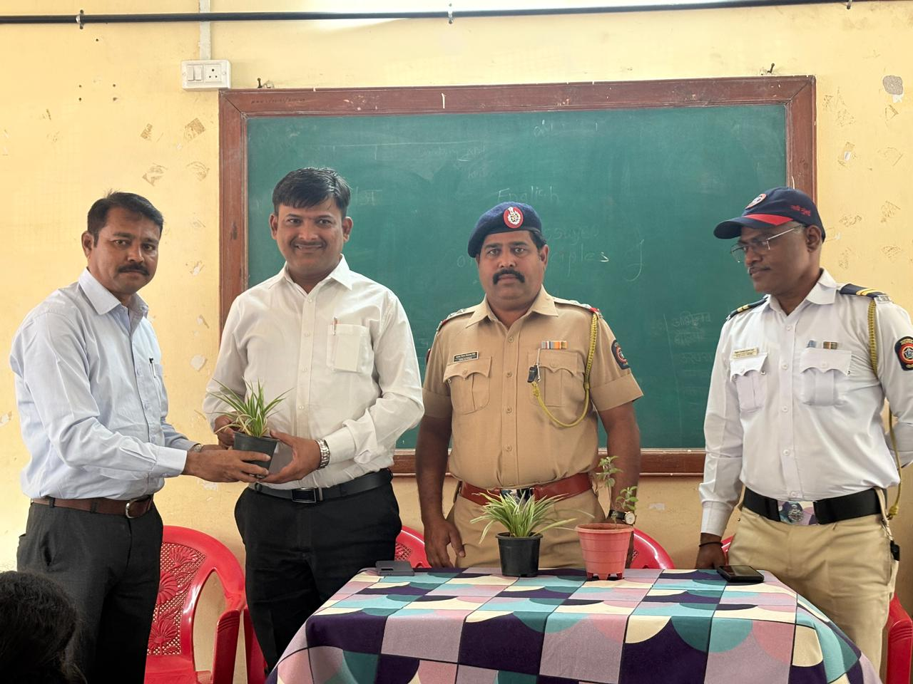

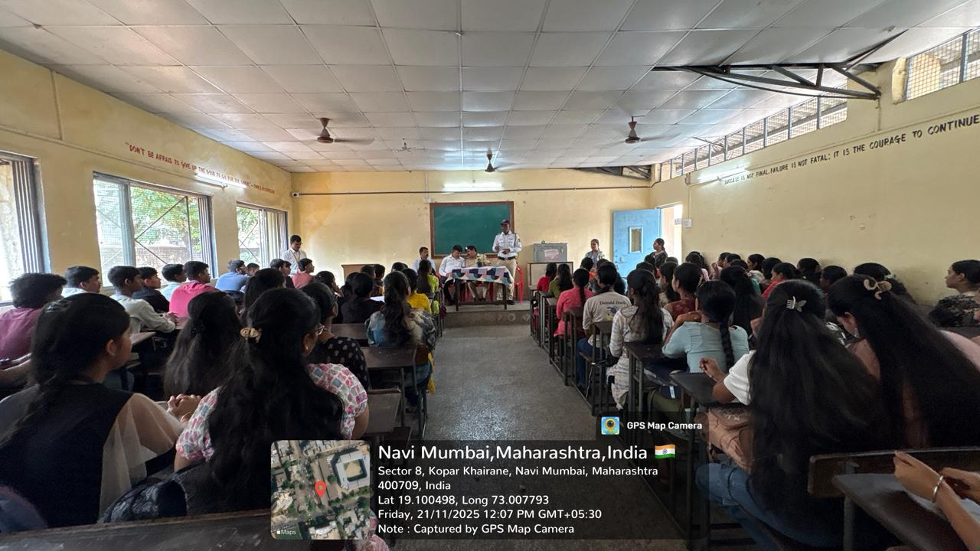

OBJECTIVE OF PROGRAM: To create awareness among students about traffic rules and road safety, and to encourage responsible behavior while using public roads.
DATE: 21/11/2025
LOCATION: F.G NAIK COLLEGE Classroom
PARTICIPATING STAFF: All the NSS volunteers, teaching and the non-teaching staff of the college.
NUMBER OF VOLUNTEERS PARTICIPATING: 24
The NSS Unit organized a Lecture on Traffic Rules Awareness in the classroom to educate students about the importance of following traffic rules and regulations. The lecture covered basic traffic signs, road safety measures, pedestrian safety, and the use of helmets and seat belts.
Students actively listened and participated in the session, gaining valuable knowledge about preventing road accidents and ensuring personal as well as public safety. The lecture helped in developing a sense of discipline and responsibility among the students.
PROGRAM DETAILS: The program commenced with a formal introduction, creating a focused and informative environment for the lecture.
The NSS Unit successfully conducted the Lecture on Traffic Rules Awareness in the classroom, emphasizing the importance of road safety and strict adherence to traffic rules.

NSS IQAC
PROGRAM OFFICER CO-ORRDINATOR I/C PRINCIPAL

